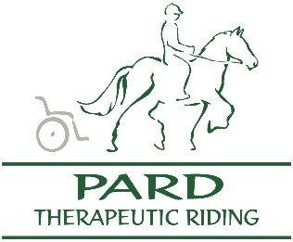

Confirmation of AODA Training
PARD Volunteers

Please complete the following after you have taken each required training module. Completed Confirmation of Training forms can be scanned and emailed to pardtherapeuticriding@gmail.com or handed in to a Board Member at Tuesday/Thursday evening riding lessons.

Training Module | Format | Date Completed
Part 1:  Customer Service | Video  Text
Part 2:  General Requirements | Video  Text
Part 3:  Ontario Human Rights Code | Video (all 5 videos)  Text

Name:

Signature:

Date:

